|  |
| --- |
| College LaSalle |
| Project - Oriented Object Programming User and Technical Manual |
|  |
| Presented to: Mihai Maftei. |

|  |
| --- |
| Mickael Lavigueur-Leduc  4/13/2023  Version: 1.1 |

1. **Start by adding a short description of your project, and the languages (technologies) used:**
2. Language: C#
3. Tools (IDE): Visual Studio 2022
4. **Present the print screens of yours forms, and have a detailed description of the functionalities (step by step).**

1-Clicking on the tab will change the button

2- On click the button will open the appropriate form linked to the button(ex. Lotto Max/Lotto649)

3- Click on exit will open a message box to confirm the exit with a yes or no

4-when “Yes” is chosen the program will close

5-when “No” is chosen the message box will close and the dashboard will remain

1. Generate button will generate a random number (8 time for max,7 for 649) and generate an id then write to lotto number inside the Lotto Log
2. Read file will pop up the form Textpop to display the content of the Lotto Log(contain both lotto inside)
3. Back button will display a message box to confirm the return to the dashboard with an yes/no selection if yes is selected then the form will close

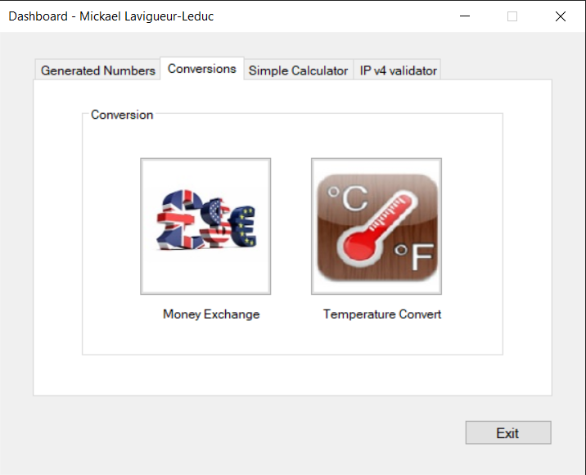

1-Clicking on the tab will change the button

2- On click the button will open the appropriate form linked to the button(ex. Money Exchange/Temperature Convert)

3- Click on exit will open a message box to confirm the exit with a yes or no

4-when “Yes” is chosen the program will close

5-when “No” is chosen the message box will close and the dashboard will remain

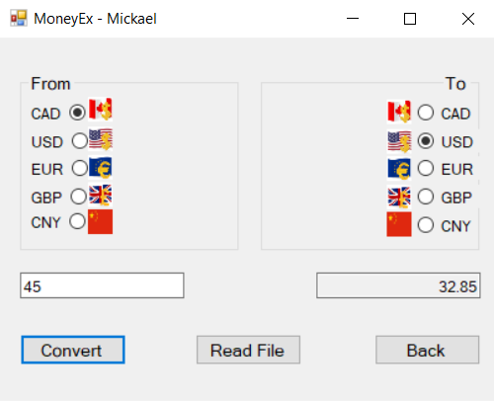

1.When the form open a timer will start counting

2. Convert button will change the currency to usd and then to the selected currency then will write inside the currency log

3.read file will display the textpop with the information currency log

4. Back button will display a message box to confirm the return to the dashboard with an yes/no selection if yes is selected then the form will close

5. a message box will open with the time stayed on the form

1. Convert will take the first number and then convert it to the selected temperature and then will write it
2. Read file

1-Clicking on the tab will change the button

2- On click the button will open the appropriate form linked to the button(ex. Calculator)

3- Click on exit will open a message box to confirm the exit with a yes or no

4-when “Yes” is chosen the program will close

5-when “No” is chosen the message box will close and the dashboard will remain

1-Clicking on the tab will change the button

2- On click the button will open the appropriate form linked to the button(ex. Ip Validator)

3- Click on exit will open a message box to confirm the exit with a yes or no

4-when “Yes” is chosen the program will close

5-when “No” is chosen the message box will close and the dashboard will remain

1. **Present the code of your application (forms).**A screen shot of a computer program

   Description automatically generated with medium confidence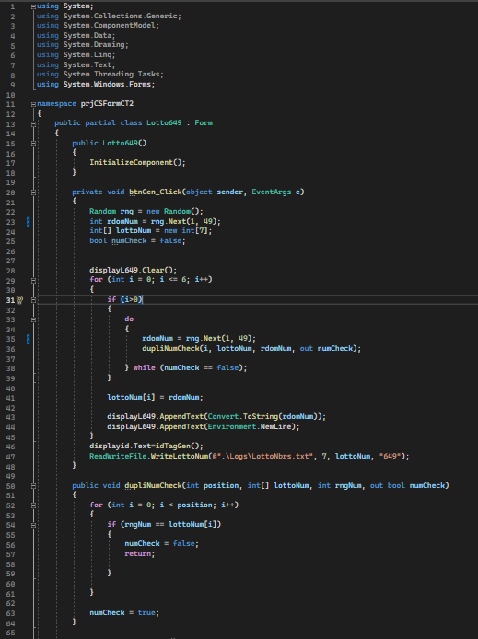A picture containing text, screenshot, software, multimedia software

   Description automatically generated

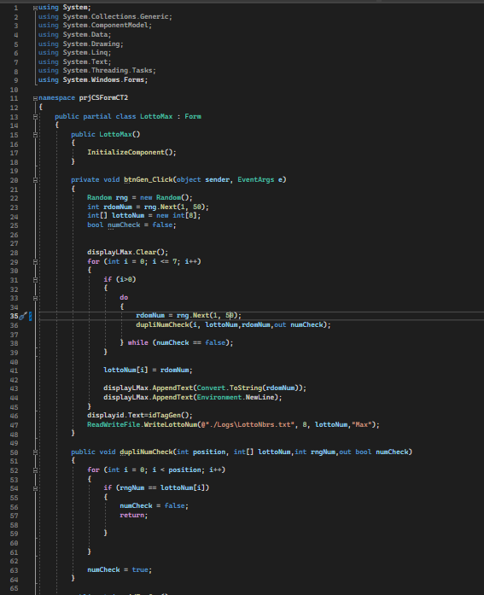

1. **Present the classes and/or methods that you create or you did use in the project.**

|  |  |
| --- | --- |
| **Class/Method Name** | **Description** |
| 1. calculator | Calculator with the addition multiplication division substraction |
| 1. Void ADD | Enter the first number into memory and the + sign into memory |
| 1. Void equal | Does the operation depending on the stored sign |
| 1. Calcmem() | Memory on the calculator with all the operation and operator |

1. **Present the difficulties that you have, what was the hardest and the easiest part of your project.**

Calculator was the most difficult part on my side

The rest went pretty well wish I could have push the ui a bit more